STOCKBURY COMMUNITY BUS

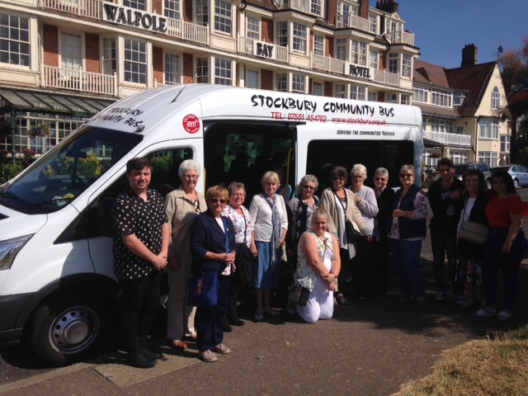
Wednesday 12th July saw the latest ‘Day Trip’ of the Stockbury Community Bus and a first for Kevin, our newest volunteer driver recruit.

We had very nearly a full bus with 15 passengers heading down to Cliftonville, just outside Margate for a Strawberry Cream Tea at The Walpole Bay Hotel. We set off around midday and slowly made our way out of the village through Sittingbourne, Teynham, Ospringe and Faversham, deliberately avoiding the motorway. Yes you've guessed it, the prettier route, before heading down to the coast via the A299.

We arrived a little before 2pm and paused along Westgate Sea Front to watch the waves and take in the sea air before finally arriving at the Walpole Bay Hotel for our afternoon visit. We were met by the staff and shown to our reserved seating which was a long decorated table capable of seating all of our party. An introduction to and a brief history of the hotel by the owner Mrs Jane Bishop followed, who gave us an amusing and informative albeit potted history of the surroundings which ended with an invitation to wander freely around the hotel looking for and taking in all that she had said.

The Strawberry Cream Tea was enjoyed by all who indulged and the group then split up to wander around the hotel as invited or walk outside to take in more of the sea air. We left the hotel at around 4:15pm and this time took the motorway to return to the village having enjoyed our afternoon cream tea and jaunt to the coast.

All in all a good time had by all, complete with a small quiz provided to complete on the journey.

We discussed our next trip, which will probably be early in September - so watch this space for details!!!!!

